H.T No
Regulations:
A15


Sreenidhi Institute of Science and Technology
(An Autonomous Institution)
Code No: 5B627 Date: 03-Feb-2020 (AN)

B.Tech III-Year II-Semester External Examination, Jan/Feb - 2020 (Supplementary)
ADDITIVE MANUFACTURING TECHNOLOGIES (ME)

Time: 3 Hours Max.Marks:75

Note: a) No additional answer sheets will be provided.
b) All sub-parts of a question must be answered at one place only, otherwise it will not be valued.
c) Missing data can be assumed suitably.

Part - A Max.Marks:25

Answer all QUESTIONS.

1. | Classify various RP technologies based on the material used. | [3M]
2. | Explain the advantages and limitations of FDM process. | [3M]
3. | Explain the advantages and applications of SLS process. | [3M]
4. | Distinguish between conventional tooling and rapid tooling. | [3M]
5. | What are the advantages of STL format? | [3M]
6. | Explain the features of Mimics and 3D doctor softwares. | [2M]
7. | What is meant by virtual prototyping? | [2M]
8. | What is the difference between rapid tooling and rapid manufacturing? | [2M]
9. | What are the two types of STL file formats ? What is their significance? | [2M]
10. | What are the process parameters of SLA system that influence the part quality? | [2M]

Part – B Max.Marks:50
ANSWER ANY FIVE QUESTIONS. EACH QUESTION CARRIES 10 MARKS.

11. | a) | Describe the historical development of RP and related technologies. | [5M]
 | b) | What are the three phases of prototyping? Explain their significance and contribution. | [5M]
12. | a) | With a diagram Describe the process of working of stereo lithography process. | [5M]
 | b) | Explain the principle of SGC process. | [5M]
13. | a) | Using a sketch to illustrate your answer, describe the selective laser sintering process. | [5M]
 | b) | Explain the advantages and applications of 3D printing process. | [5M]
14. | a) | Explain the spray metal deposition process with a figure. | [5M]
 | b) | Give the classification of rapid tooling. | [5M]
15. | a) | What are the consequences of building a invalid tessellated model? | [5M]
 | b) | Compose the ASCII STL file information for the shaded facet given below.  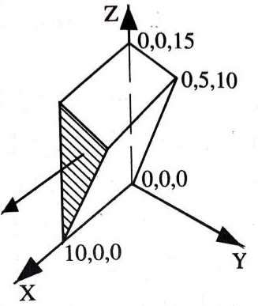 | [5M]
16. | a) | What are the typical applications of RP in design? Briefly describe these applications and illustrate them with examples. | [5M]
 | b) | Explain the RP applications in engineering and analysis. | [5M]
17. | a) | Differentiate subtractive Prototyping process and Additive Prototyping process. | [4M]
 | b) | Compare between FDM and LOM process | [3M]
 | c) | Describe the differences between selective laser sintering and three-dimensional printing process. | [3M]
18. | a) | Derive the expression of build time of a simple cube for printing all the layers using FDM process. Consider for cube: height h, breadth b and width w. Tr is the Repositioning time. | [4M]
 | b) | With illustration explain the Missing facets STL file problems | [3M]
 | c) | Explain the features of various RP softwares in brief. | [3M]

-- 00 -- 00 –

